 | 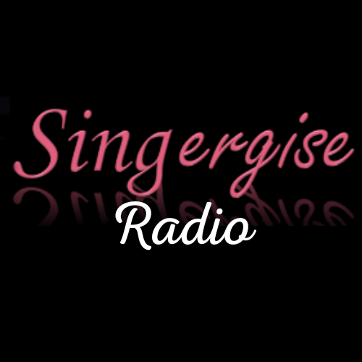

DJ4aDay CIC– Radio Broadcasting, Music & Ukulele Workshop
Connect• Collaborate• Create
www.DJ4aDay.co.uk

Family Registration Form
Thank you for your interest in the DJ4aDay workshops. Join us for a fun, interactive family workshop where you will learn how a radio programme is created, develop presenting and interviewing skills, discover what happens behind the scenes in a radio studio and enjoy an Introduction to the Ukulele.
Every workshop session includes the opportunity for participants to take part in a LIVE broadcast on Singergise Radio.
Venue: Panteg House, Griffithstown, NP4 5BE
Funded by: Torfaen County Borough Council – Community Cohesion Grant

Important Information
- Suitable for children aged 8 years and over.
- All children must be accompanied by a responsible adult (18+) throughout the workshop.
- One registration form per family.
- Places are limited and booking is confirmed by email.

1. Preferred Workshop Session – please mark with an X
Session 1 – Monday 17 August | 10:00am–12:30pm
Session 2 – Monday 17 August | 1:00pm–3:30pm
Session 3 – Tuesday 18 August | 10:00am–12:30pm
Session 4 – Tuesday 18 August | 1:00pm–3:30pm
Session 5 – Wednesday 19 August | 10:00am–12:30pm
Session 6 – Wednesday 19 August | 1:00pm–3:30pm
If your preferred session is full, would you like another session? ☐ Yes ☐ No If so which session? __________

2. Lead Adult Details
Full Name: ________________________________________________
Email Address: _____________________________________________
Telephone Number: _________________________________________

3. Family Members Attending – Please add additional rows if required.
Adults: ____ Children (aged 8+): ____
Name | Adult/Child | Child Age Range
1. |  | ☐8–10 ☐11–13 ☐14–16 ☐17+
2. |  | ☐8–10 ☐11–13 ☐14–16 ☐17+
3. |  | ☐8–10 ☐11–13 ☐14–16 ☐17+
4. |  | ☐8–10 ☐11–13 ☐14–16 ☐17+
5. |  | ☐8–10 ☐11–13 ☐14–16 ☐17+
6. |  | ☐8–10 ☐11–13 ☐14–16 ☐17+

4. Emergency Contact
Name: __________________
Telephone: __________________
Relationship: __________________

5. Health & Accessibility
Please let us know about any medical conditions, /allergies/dietary/accessibility needs or additional support requirements.
____________________________________________________
____________________________________________________

6. Photography/Video Consent
Photographs and video may be taken during the workshops to promote future community activities through printed publicity, social media, websites and funding reports.
☐ Yes, I give permission.
☐ No, I do not give permission.

7. Monitoring Information (Optional)
Postcode: __________
First family workshop? ☐ Yes ☐ No
Interested in: ☐ Radio ☐ Presenting ☐ Interviewing ☐ Ukulele ☐ Family activity ☐ Other
Heard about us: ☐ School ☐ Facebook ☐ Friend ☐ Community Organisation ☐ Poster ☐ Website ☐ Other

8. Additional Information – is there anything else you would like us to know?
____________________________________________________
____________________________________________________

Privacy Notice
Your information will only be used to manage your booking, support safeguarding, communicate about the workshop and provide anonymous monitoring information to the grant funder. It will be stored securely in accordance with UK data protection legislation.

Declaration (please tick all boxes)
☐ I confirm all children attending are aged 8 years or over.
☐ I understand children must be accompanied by a responsible adult (18+) throughout the workshop.
☐ I confirm the information provided is accurate.
☐ I understand my booking is not confirmed until I receive a confirmation email.
Signature: ____________________________ Date: __________________

THANK YOU FOR REGISTERING – We look forward to welcoming you and your family to Panteg House for a fun, interactive and engaging Radio and Music Broadcasting Experience.

Should you require further information – please contact – Susie info@DJ4aDay.co.uk

